**What happens when a square wave is applied to circuitry that does not pass all the necessary frequency components? The resultant output is a distorted square wave.**

* 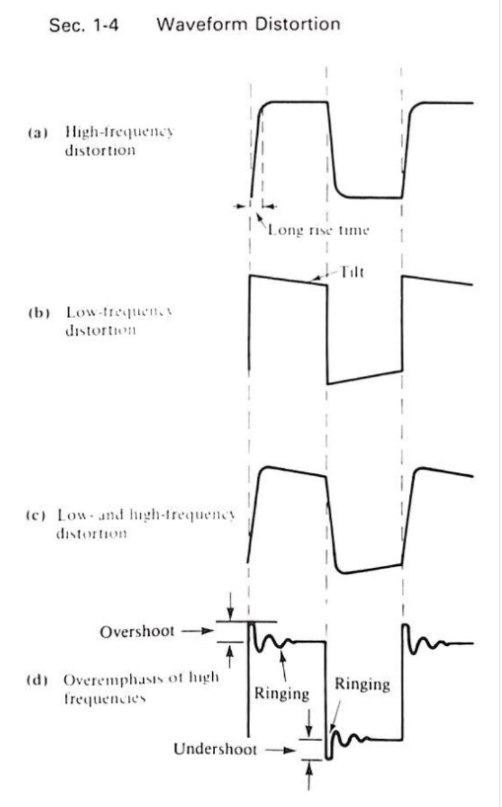**Three main types of waveform distortions**:
  + **Increased Rise & Fall Times $t_{r} \& t_{f}$** as seen in image a, is due to High Frequency Distortion.
    - **High Frequency Distortion** is caused by parallel capacitance.
  + **Tilt** indicates Low Frequency Distortion.
    - **Low Frequency Distortion** is caused by series capacitance.
  + **Ringing** is High Frequency Distortion and occurs when a circuit oscillates for a short time due to the presence of stray inductance and capacitance.
  + When circuits overemphasize some of the high-frequency harmonics, **Overshoots** and **Undershoots** are produced.

**References**:

Bell, D. A. (1997). *Solid state pulse circuits*. Sarnia, ON: David A. Bell.